Vishal Jagannath Khot

parle sale data analysis

PROJECT INPUTS

Date range: Jan 2021 to May 2021

Product Categories: Data has 3 product categories namely Bars, Bites, Others

Products: 3 different product categories have total of 22 products and their classification as follows:

|  |  |  |  |  |  |
| --- | --- | --- | --- | --- | --- |
| Category | Product | Category | Product | Category | Product |
| Bars | 85% Dark Bars | Bites | 50% Dark Bites | Others | Drinking Coco |
|  | 99% Dark & Pure |  | 70% Dark Bites |  | Organic Choco Syrup |
|  | Almond Choco |  | After Nines |  | Manuka Honey Choco |
|  | Baker's Choco Chips |  | Choco Coated Almonds |  | White Choc |
|  | Caramel Stuffed Bars |  | Eclairs |  |  |
|  | Fruit & Nut Bars |  | Peanut Butter Cubes |  |  |
|  | Milk Bars |  | Spicy Special Slims |  |  |
|  | Mint Chip Choco |  |  |  |  |
|  | Raspberry Choco |  |  |  |  |
|  | Smooth Silky Salty |  |  |  |  |
|  | Orange Choco |  |  |  |  |
| Count | 11 | Count | 7 | Count | 4 |

State: Sale record include 6 states data

Maharashtra, Karnataka, Punjab, Tamil Nadu, Rajasthan, Assam

Salesperson Teams: we have 3 different teams namely as Delish, Jucies, Yummies. These 3 teams have consisted of 20 salesperson which classified as follows:

|  |  |  |  |  |  |
| --- | --- | --- | --- | --- | --- |
| Team | Sales Person | Team | Sales Person | Team | Sales Person |
| Delish | Navnath Kamble | Jucies | Vishal Narwade | Yummies | Radha Gawane |
|  | Jaya Sarang |  | Vikas Rajdar |  | Vinay Rathod |
|  | Mayanti Patil |  | Rajesh Parte |  | Rakesh Mishra |
|  | Maya Pawar |  | Ram Jadhav |  | Sonali Pawar |
|  | Priyanka More |  | Kamal Hange |  | Ketaki Patil |
|  | Suraj Mane |  | Samadhan Ahire |  | Sita Jadhav |
|  | Uma Sathe |  | Jayesh kale |  |  |
| Count | 7 | Count | 7 | Count | 6 |

Data insights:

PROFIT%:

53%

TOTAL PROFIT:

42,41,808

42.41 L

TOTAL REVENUE:

80,16,442

80.16 L

TOTAL COST:

37,74,634

37.75 L

Trend Data Insights:

* Period: Jan to May
* Sale:26 % drop Cost:8 % drop Profit: 39% drop Profit%=10% drop

Sale Revenue Trend

* Average sale revenue during first 4 months registered 1680k then sharply drop to 1300k.
* Highest revenue registered in January month(1753k). sale revenue did not show much variation in revenue generation in first 4 Months but it did not reflect in profit generation as profit continuously decreases.
* Lowest revenue recorded In May Month(1300k) 21% drop from average revenue.

Products Cost Trend

* February Month registered lowest cost input 647k which generates highest profit Margin in system. Second lowest in May month i.e., 4.32% high than lowest input cost but could generates sequential profit margin.
* March and April registered high cost which result in decrease in profit.
* Sharp cost input i.e., 32% occurs in March Month as compare to previous Month but results in 6.5% increase in sale amount, 10% drop in profit and profit Margins
* April Month registered highest cost input 873k i.e., 2.8% higher than Previous Month It registered 10.50% drop in profit and 3% drop in profit margin.

Profit Tend

* Profit continuously decreased from Jan to May Month
* Highest profit registered in January Month (1021k) 63.3% more than lowest in May Month(625k)
* Profit showing invariance with respect to Sale revenue and profit margins.

Profit Margin Trend

* January and February registered high profit margin 58% and 60% respectively. From March onwards profit margin decrease continuously till marginal uptake in May month.
* Sharpest declined occurs in March Month account 10 % margin from February Month

Product Category

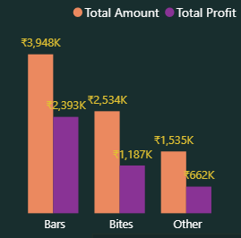

Profit: Revenue ratio highest in others category i.e. 57% Bites has 53% whereas Bars has 44%

Among 3 product Categories, Bars records highest revenue and profits

Bars category records 55.8% more revenue and almost double profit than second most bites category

Sales person performance

During Jan-May period, sales person performance compiled and produced as follow:

Top 5 Revenue Generating salesperson

Delish team performing excellent in revenue generation as 4/5 belongs to this team

|  |  |  |
| --- | --- | --- |
| Salesperson | Team | Revenue |
| Suraj Mane | Delish | 459k |
| Priyanka More | Delish | 447k |
| Ram Jadhav | Juices | 445k |
| Mayanti Patil | Delish | 431k |
| Jaya Sarang | Delish | 426k |
|  |  | 2208k |

Top 5 profit Generating salesperson

Delish team performing excellent in revenue generation as all belongs to this team

|  |  |  |
| --- | --- | --- |
| Salesperson | Team | Profit |
| Jaya Sarang | Delish | 263k |
| Suraj Mane | Delish | 247k |
| Priyanka More | Delish | 243k |
| Maya Pawar | Delish | 231k |
| Navnath Kamble | Delish | 230k |
|  |  | 1214k |

Top 5 profit Margin Generating salesperson

Delish team has 3 members whereas Yummies team has 2 members in this list

|  |  |  |
| --- | --- | --- |
| Salesperson | Team | Profit Margin |
| Navnath Kamble | Delish | 62% |
| Jaya Sarang | Delish | 62% |
| Maya Pawar | Delish | 57% |
| Ketaki Pawar | Yummies | 55% |
| Sita Jadhav | Yummies | 55% |

Product Category

Data has 3 product categories namely as Bars, Bites and Others.

* Bar Category Products has highest sales and profit followed by Bites and Others
* Bars category records 55.8% more revenue and almost double profit than second most bites category
* Profit: Revenue ratio highest in others category i.e., 57% Bites has 53% whereas Bars has 44%. (Generating high profit with respect to their sale amount)

Bars has 359 more order than second most Bite Category (55% more than Bites). Other category has 379 orders.

PRODUCT CATEGORY: BARS

TOTAL PROFIT:

23.94 LAKH

TOTAL REVENUE:

39.5 LAKH

BOXES:

242K

TOTAL ORDER:

1008

STATE DISTRIBUTION:

|  |  |  |  |  |  |
| --- | --- | --- | --- | --- | --- |
| State | Orders | Boxes | Revenue | Profit | Profit% |
| Karnataka | 174 | 39180 | 684k | 436k | 64% |
| Assam | 171 | 37516 | 610k | 359k | 59% |
| Maharashtra | 166 | 40725 | 686k | 425k | 62% |
| Punjab | 158 | 38902 | 644k | 389k | 61% |
| Rajasthan | 173 | 43790 | 665k | 391k | 59% |
| Tamil Nadu | 166 | 42181 | 663k | 394k | 59% |
| Total | 1008 | 242k | 39.5 Lakh | 23.94 Lakh | 61% |

Low Output State: Assam High Output State: Maharashtra, Karnataka

ASSAM

Top Products:

|  |  |  |  |  |  |
| --- | --- | --- | --- | --- | --- |
| Product | Orders | Boxes | Revenue | Profit | Profit% |
| Fruits & Nut Bars | 11 | 1031 | 43.1k | 38.2k | 89 |
| Smooth Silky Salts | 16 | 2635 | 63k | 55.7k | 88 |
| Caramel Stuffed Bars | 19 | 3125 | 91.9k | 65.4k | 71 |

Bottom Products:

|  |  |  |  |  |  |
| --- | --- | --- | --- | --- | --- |
| Product | Orders | Boxes | Revenue | Profit | Profit% |
| Baker’s Choco Chips | 14 | 5346 | 60.3k | -6k | -10 |
| 85% Dark Bars | 17 | 3990 | 57.5k | 15.6k | 27 |
| Orange Choco | 18 | 4233 | 41.4k | 25.9k | 62 |

KARNATAKA

Top Products:

|  |  |  |  |  |  |
| --- | --- | --- | --- | --- | --- |
| Product | Orders | Boxes | Revenue | Profit | Profit% |
| Smooth Silky Salts | 18 | 2412 | 52.3k | 45.6k | 87 |
| Fruits & Nut Bars | 16 | 3497 | 90k | 73.5k | 81 |
| Mint Chip Choco | 12 | 2888 | 80.9k | 64.3k | 80 |

Bottom Products:

|  |  |  |  |  |  |
| --- | --- | --- | --- | --- | --- |
| Product | Orders | Boxes | Revenue | Profit | Profit% |
| Baker’s Choco Chips | 15 | 2957 | 33.2k | -3.5k | -11 |
| 85% Dark Bars | 16 | 3700 | 62.4k | 23.5k | 38 |
| 99% Dark & Pure | 17 | 4218 | 75.3k | 42.7k | 57 |

MAHARASHTRA

Top Products:

|  |  |  |  |  |  |
| --- | --- | --- | --- | --- | --- |
| Product | Orders | Boxes | Revenue | Profit | Profit% |
| Smooth Silky Salts | 17 | 4185 | 79.9k | 68.3k | 86 |
| Raspberry Choco | 14 | 3615 | 65.5k | 51.6k | 79 |
| Fruits & Nut Bars | 16 | 3470 | 72.6k | 56.2k | 77 |

Bottom Products:

|  |  |  |  |  |  |
| --- | --- | --- | --- | --- | --- |
| Product | Orders | Boxes | Revenue | Profit | Profit% |
| Baker’s Choco Chips | 18 | 3591 | 39.5k | -5k | -13 |
| 85% Dark Bars | 19 | 5094 | 75.7k | 22.1k | 29 |
| Milk Bars | 12 | 4171 | 42.6k | 20.7k | 49 |

PUNJAB

Top Products:

|  |  |  |  |  |  |
| --- | --- | --- | --- | --- | --- |
| Product | Orders | Boxes | Revenue | Profit | Profit% |
| Smooth Silky Salts | 18 | 2623 | 54.1k | 46.9k | 87 |
| Raspberry Choco | 14 | 3359 | 50.4 | 37.5k | 74 |
| Fruits & Nut Bars | 14 | 3318 | 53.9 | 38.2k | 71 |

Bottom Products:

|  |  |  |  |  |  |
| --- | --- | --- | --- | --- | --- |
| Product | Orders | Boxes | Revenue | Profit | Profit% |
| 85% Dark Bars | 17 | 7255 | 83.4k | 7.1k | 9 |
| Caramel Stuffed Bars | 14 | 2436 | 46.9k | 26.3k | 56 |
| Baker’s Choco Chips | 13 | 2481 | 76.6k | 45.9k | 60 |

TAMIL NADU

Top Products:

|  |  |  |  |  |  |
| --- | --- | --- | --- | --- | --- |
| Product | Orders | Boxes | Revenue | Profit | Profit% |
| Smooth Silky Salts | 16 | 3774 | 74.4k | 64k | 86 |
| Mint Chip Choco | 13 | 1936 | 42.8k | 31.7k | 74 |
| Orange Choco | 16 | 4406 | 60k | 43.8k | 73 |

Bottom Products:

|  |  |  |  |  |  |
| --- | --- | --- | --- | --- | --- |
| Product | Orders | Boxes | Revenue | Profit | Profit% |
| Baker’s Choco Chips | 14 | 5772 | 60.8k | -4.5k | -8 |
| 85% Dark Bars Bars | 15 | 3068 | 46.7k | 14.5k | 31 |
| Milk Bars | 15 | 3797 | 49.5k | 29.6k | 60 |

RAJASTHAN

Top Products:

|  |  |  |  |  |  |
| --- | --- | --- | --- | --- | --- |
| Product | Orders | Boxes | Revenue | Profit | Profit% |
| Smooth Silky Salts | 15 | 3175 | 62.7k | 53.9k | 86 |
| Fruit & Nut Bars | 15 | 3367 | 67.8k | 51.8k | 76 |
| Orange Choco | 16 | 5399 | 78.6k | 58.7k | 75 |

Bottom Products:

|  |  |  |  |  |  |
| --- | --- | --- | --- | --- | --- |
| Product | Orders | Boxes | Revenue | Profit | Profit% |
| Baker’s Choco Chips | 14 | 3535 | 46.1k | 2.2k | 5 |
| Caramel Stuffed Bars | 16 | 4238 | 57.2k | 21.5k | 38 |
| 85% Dark Bars | 13 | 2561 | 43.7k | 16.7k | 38 |

High Output Products: Smooth Silky Salts Fruits & Nut Bars Orange Choco

Low Output Product: Baker’s Choco Chips

Marginal Product: 85% Darks Bars

PRODUCT CATEGORY: BITES

TOTAL ORDER:

649

TOTAL REVENUE:

25.33 LAKH

TOTAL PROFIT:

11.86 LAKH

BOXES:

194K

State Distribution:

|  |  |  |  |  |  |
| --- | --- | --- | --- | --- | --- |
| State | Orders | Boxes | Revenue | Profit | Profit% |
| Karnataka | 109 | 32002 | 391k | 166k | 42% |
| Assam | 112 | 31735 | 461k | 249k | 54% |
| Maharashtra | 112 | 34980 | 457k | 209k | 46% |
| Punjab | 109 | 32381 | 377k | 150k | 40% |
| Rajasthan | 109 | 30298 | 458k | 248k | 24% |
| Tamil Nadu | 98 | 32107 | 389k | 165k | 42% |
| Total | 649 | 194k | 25.33 Lakh | 11.87 Lakh | 47% |

Low Output state: Punjab High Output state: Rajasthan, Assam

ASSAM

Top Products:

|  |  |  |  |  |  |
| --- | --- | --- | --- | --- | --- |
| Product | Orders | Boxes | Revenue | Profit | Profit% |
| Peanut butter Cubes | 17 | 3167 | 92.9k | 84.5k | 91 |
| Choco coated Almond | 17 | 3542 | 84.4k | 72.6k | 86 |
| 70% Dark Bites | 17 | 5374 | 69k | 41.9k | 61 |

Bottom Products:

|  |  |  |  |  |  |
| --- | --- | --- | --- | --- | --- |
| Product | Orders | Boxes | Revenue | Profit | Profit% |
| After Nines | 16 | 7105 | 62.5k | -10.1k | -16 |

KARNATAKA

Top Products:

|  |  |  |  |  |  |
| --- | --- | --- | --- | --- | --- |
| Product | Orders | Boxes | Revenue | Profit | Profit% |
| Peanut butter Cubes | 16 | 3054 | 45.9k | 37.8k | 82 |
| Choco coated Almond | 16 | 3347 | 61.6k | 50.5k | 82 |
| 70% Dark Bites | 12 | 3146 | 45.1k | 29.3k | 65 |

Bottom Products:

|  |  |  |  |  |  |
| --- | --- | --- | --- | --- | --- |
| Product | Orders | Boxes | Revenue | Profit | Profit% |
| After Nines | 18 | 7308 | 72.4k | -2.3k | 3 |
| Spicy Special Slims | 15 | 7904 | 64.6k | -297 | 0 |

MAHARASHTRA

Top Products:

|  |  |  |  |  |  |
| --- | --- | --- | --- | --- | --- |
| Product | Orders | Boxes | Revenue | Profit | Profit% |
| Peanut butter Cubes | 16 | 2141 | 54.7k | 49k | 90 |
| Choco coated Almond | 16 | 2531 | 49.8k | 41.4k | 83 |
| 70% Dark Bites | 15 | 5400 | 84k | 56.8k | 68 |

Bottom Products:

|  |  |  |  |  |  |
| --- | --- | --- | --- | --- | --- |
| Product | Orders | Boxes | Revenue | Profit | Profit% |
| After Nines | 18 | 9558 | 78.3k | -19.4k | -25 |

PUNJAB

Top Products:

|  |  |  |  |  |  |
| --- | --- | --- | --- | --- | --- |
| Product | Orders | Boxes | Revenue | Profit | Profit% |
| Peanut butter Cubes | 16 | 2451 | 57.4k | 50.9k | 89 |
| Choco coated Almond | 15 | 3635 | 57k | 44.9k | 79 |
| 70% Dark Bites | 16 | 4228 | 54.2k | 32.9k | 61 |

Bottom Products:

|  |  |  |  |  |  |
| --- | --- | --- | --- | --- | --- |
| Product | Orders | Boxes | Revenue | Profit | Profit% |
| After Nines | 16 | 8419 | 64k | -22k | 34 |
| Spicy Special Slims | 15 | 6177 | 50.4k | -276 | -1 |

TAMIL NADU

Top Products:

|  |  |  |  |  |  |
| --- | --- | --- | --- | --- | --- |
| Product | Orders | Boxes | Revenue | Profit | Profit% |
| Peanut butter Cubes | 10 | 2651 | 65.1k | 58k | 89 |
| Choco coated Almond | 16 | 3230 | 75k | 64.3k | 86 |
| 70% Dark Bites | 13 | 2984 | 30k | 15k | 50 |

Bottom Products:

|  |  |  |  |  |  |
| --- | --- | --- | --- | --- | --- |
| Product | Orders | Boxes | Revenue | Profit | Profit% |
| After Nines | 16 | 5907 | 60.8k | 457 | 1 |
| Spicy Special Slims | 15 | 8611 | 73.9k | 3.2k | 4 |
| 50% Dark Bites | 15 | 4686 | 44.7k | 9.6k | 22 |

RAJASTHAN

Top Products:

|  |  |  |  |  |  |
| --- | --- | --- | --- | --- | --- |
| Product | Orders | Boxes | Revenue | Profit | Profit% |
| Peanut butter Cubes | 14 | 1812 | 61.8k | 57k | 92 |
| Choco coated Almond | 16 | 1997 | 50.6k | 44k | 87 |
| 70% Dark Bites | 18 | 4617 | 87.1k | 63.8k | 73 |

Bottom Products:

|  |  |  |  |  |  |
| --- | --- | --- | --- | --- | --- |
| Product | Orders | Boxes | Revenue | Profit | Profit% |
| After Nines | 16 | 4799 | 48k | -1k | -2 |
| Spicy Special Slims | 13 | 6913 | 72.2k | 15.3k | 21 |

High Output Products: Peanut Butter Cubes (lowest order but Highest profit margin), Choco Coated Almonds,70% Dark Bites

Low Output Product: After Nines (loss Making Product), Spicy Special Slims

PRODUCT CATEGORY: OTHER

TOTAL ORDER:

379

TOTAL REVENUE:

15.35 LAKH

TOTAL PROFIT:

6.61 LAKH

BOXES:

106K

State Distribution:

|  |  |  |  |  |
| --- | --- | --- | --- | --- |
| State | Orders | Boxes | Revenue | Profit |
| Karnataka | 66 | 20126 | 288k | 124k |
| Assam | 56 | 14872 | 223k | 99k |
| Maharashtra | 64 | 19575 | 267k | 104k |
| Punjab | 63 | 16136 | 243k | 113k |
| Rajasthan | 64 | 18435 | 260k | 108k |
| Tamil Nadu | 66 | 17032 | 254k | 114k |
| Total | 379 | 106k | 15.35 Lakh | 6.61 Lakh |

High output State: Karnataka Low output State: Assam

ASSAM

Top Products:

|  |  |  |  |  |  |
| --- | --- | --- | --- | --- | --- |
| Product | Orders | Boxes | Revenue | Profit | Profit% |
| White Choc | 15 | 3041 | 52.3k | 32.8k | 63 |

Bottom Products:

|  |  |  |  |  |  |
| --- | --- | --- | --- | --- | --- |
| Product | Orders | Boxes | Revenue | Profit | Profit% |
| Organic Choco Syrup | 14 | 4475 | 66.3k | 23.5k | 35 |

KARNATAKA

Top Products:

|  |  |  |  |  |  |
| --- | --- | --- | --- | --- | --- |
| Product | Orders | Boxes | Revenue | Profit | Profit% |
| White Choc | 16 | 5633 | 98.7k | 62.5k | 63 |

Bottom Products:

|  |  |  |  |  |  |
| --- | --- | --- | --- | --- | --- |
| Product | Orders | Boxes | Revenue | Profit | Profit% |
| Organic Choco Syrup | 18 | 6180 | 66.5k | 7.3k | 11 |

MAHARASHTRA

Top Products:

|  |  |  |  |  |  |
| --- | --- | --- | --- | --- | --- |
| Product | Orders | Boxes | Revenue | Profit | Profit% |
| White Choc | 14 | 4144 | 56.7k | 30.1k | 53 |

Bottom Products:

|  |  |  |  |  |  |
| --- | --- | --- | --- | --- | --- |
| Product | Orders | Boxes | Revenue | Profit | Profit% |
| Organic Choco Syrup | 16 | 5671 | 79.1k | 24.9k | 31 |

PUNJAB

Top Products:

|  |  |  |  |  |  |
| --- | --- | --- | --- | --- | --- |
| Product | Orders | Boxes | Revenue | Profit | Profit% |
| Manuka Honey Choco | 19 | 6314 | 97.7k | 57.7k | 56 |

Bottom Products:

|  |  |  |  |  |  |
| --- | --- | --- | --- | --- | --- |
| Product | Orders | Boxes | Revenue | Profit | Profit% |
| Organic Choco Syrup | 14 | 4503 | 51.5k | 8.4k | 16 |

TAMIL NADU

Top Products:

|  |  |  |  |  |  |
| --- | --- | --- | --- | --- | --- |
| Product | Orders | Boxes | Revenue | Profit | Profit% |
| Manuka Honey Choco | 14 | 4689 | 68.1k | 36.3k | 53 |

Bottom Products:

|  |  |  |  |  |  |
| --- | --- | --- | --- | --- | --- |
| Product | Orders | Boxes | Revenue | Profit | Profit% |
| Organic Choco Syrup | 16 | 4398 | 58.6k | 16.5k | 28 |

RAJASTHAN

Top Products:

|  |  |  |  |  |  |
| --- | --- | --- | --- | --- | --- |
| Product | Orders | Boxes | Revenue | Profit | Profit% |
| White Choc | 16 | 3486 | 53.7k | 31.3k | 58 |

Bottom Products:

|  |  |  |  |  |  |
| --- | --- | --- | --- | --- | --- |
| Product | Orders | Boxes | Revenue | Profit | Profit% |
| Organic Choco Syrup | 16 | 5885 | 68.8k | 12.5k | 18 |

High output Product: White Chocolate, Manuka Honey Choco

Low output Products: Organic Choco Syrup

TEAM ANALYSIS

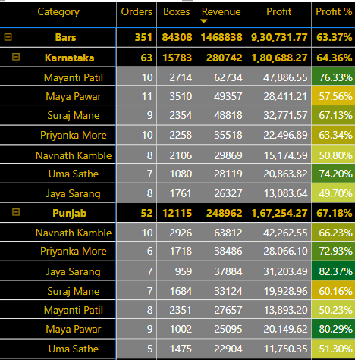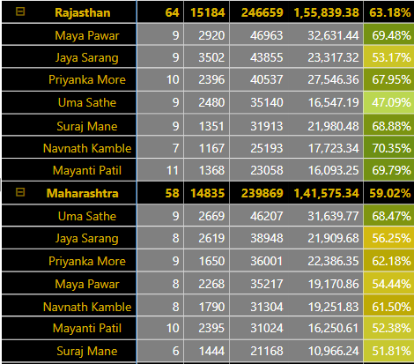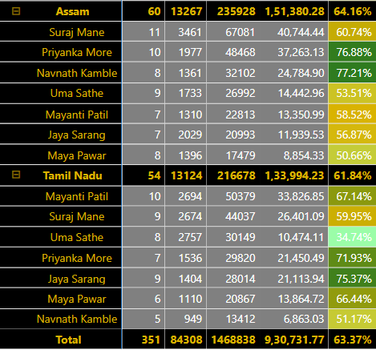

TEAM: DELISH

PROFIT %: 63%

PROFIT: 930K

REVENUE:1468K

ORDERS:351

BOXES: 84308

PRODUCT CATEGORY:BARS

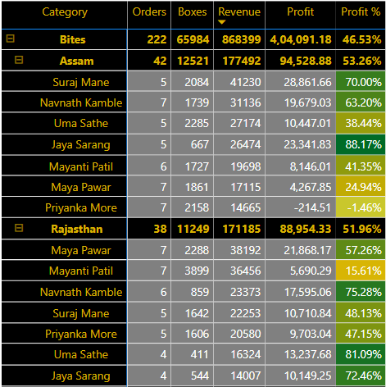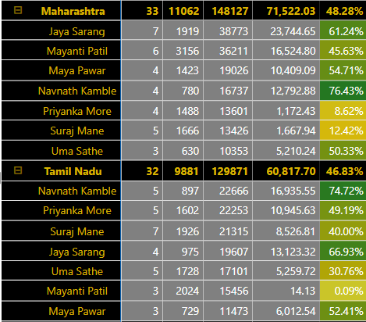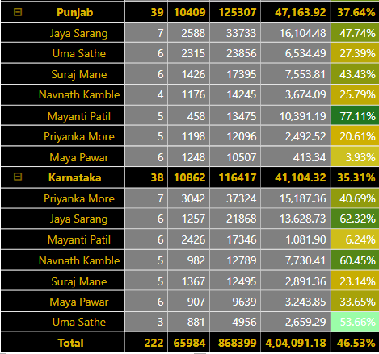

TEAM: DELISH

PROFIT: 404K

PROFIT %: 47%

REVENUE:868K

BOXES: 65984

ORDERS:222

PRODUCT CATEGORY:BITES

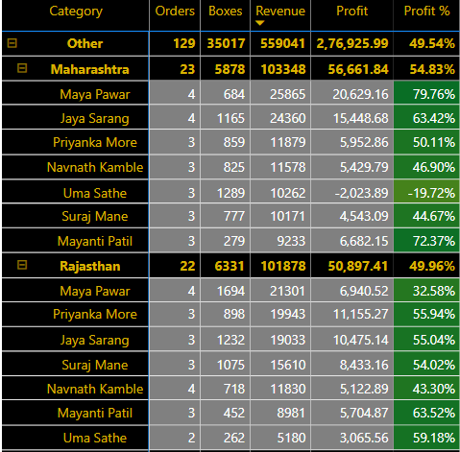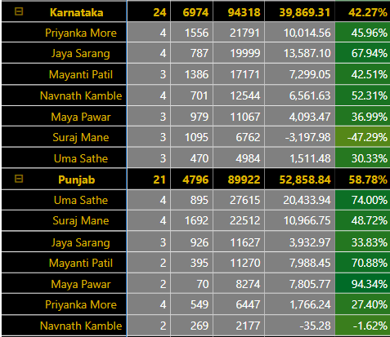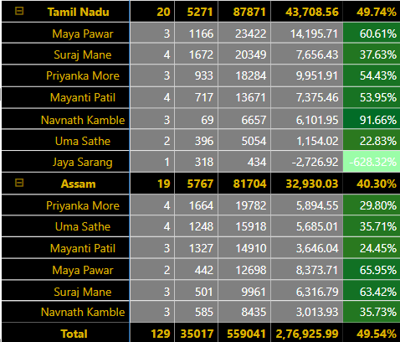

TEAM: DELISH

PROFIT %: 50%

PROFIT: 277K

REVENUE:559K

BOXES: 35017

ORDERS:129

PRODUCT CATEGORY:OTHER

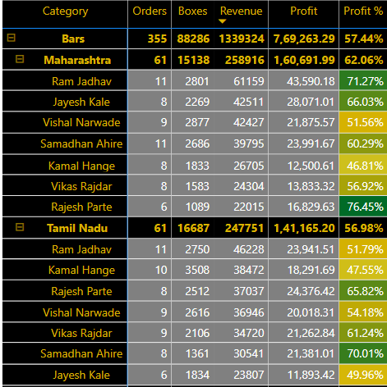

TEAM: JUCIES

REVENUE:1340K

BOXES: 88286

ORDERS:355

PRODUCT CATEGORY:BARS

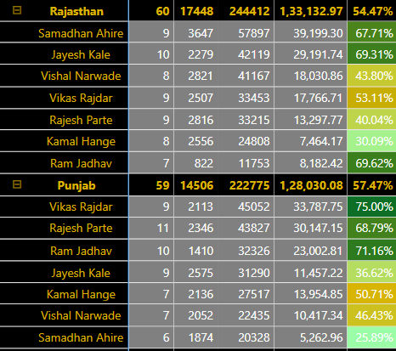

PROFIT %: 57%

PROFIT: 769K

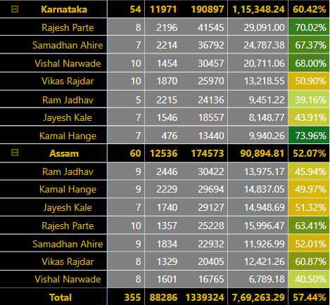

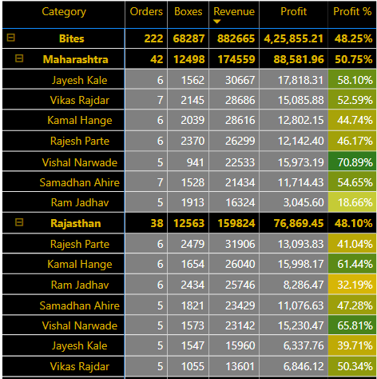

TEAM: JUCIES

BOXES: 68287

ORDERS:222

PRODUCT CATEGORY:BITES

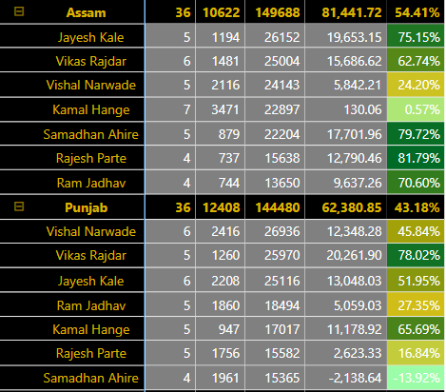

PROFIT: 426K

PROFIT %: 48%

REVENUE:882K

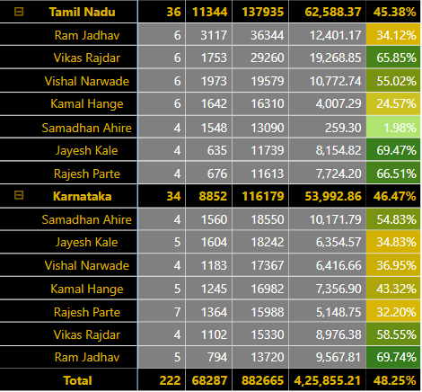

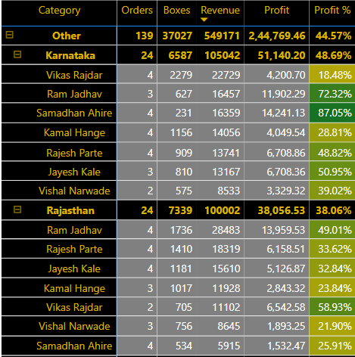

TEAM: JUCIES

REVENUE:549K

BOXES: 37027

ORDERS:139

PRODUCT CATEGORY:OTHER

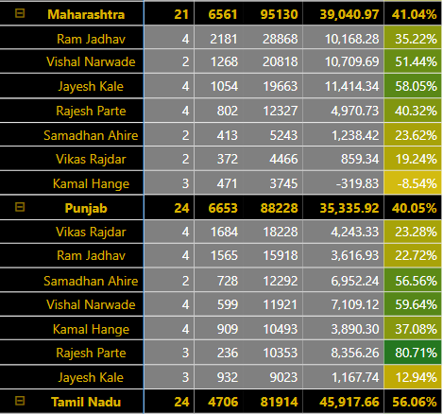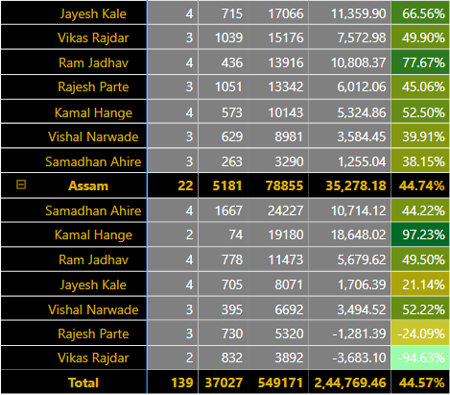

PROFIT %: 45%

PROFIT: 245K

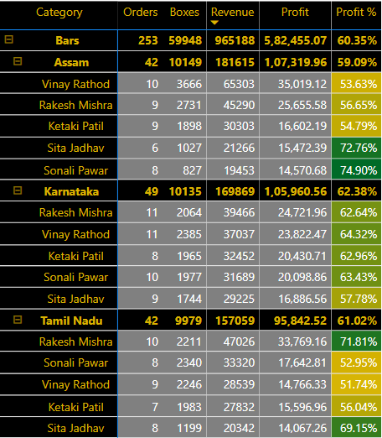

TEAM: YUMMIES

PROFIT: 582K

REVENUE:965K

BOXES:59948

ORDERS:253

PRODUCT CATEGORY:BARS

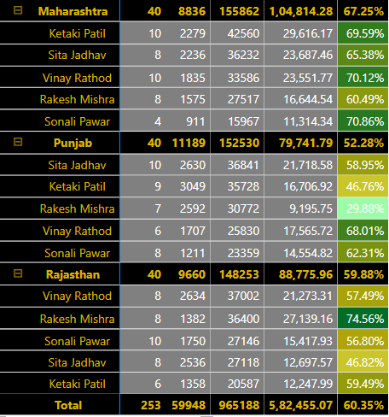

PROFIT %: 60%

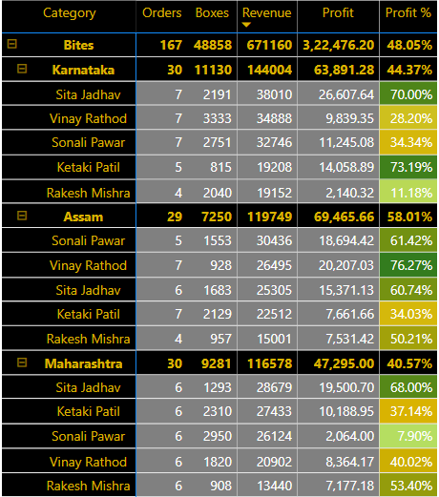

TEAM: YUMMIES

PROFIT: 322K

REVENUE:671K

BOXES: 48858

ORDERS:167

PRODUCT CATEGORY:BITES

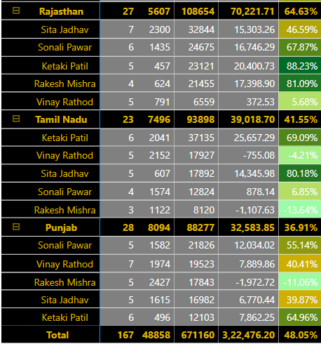

PROFIT %: 48%

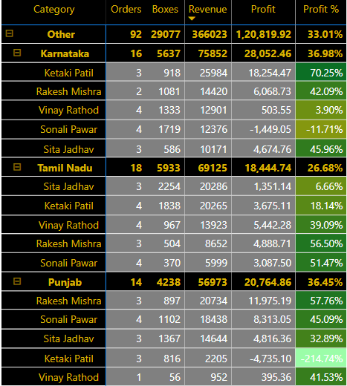

TEAM: YUMMIES

PROFIT: 245K

REVENUE:549K

BOXES: 37027

ORDERS:139

PRODUCT CATEGORY:OTHER

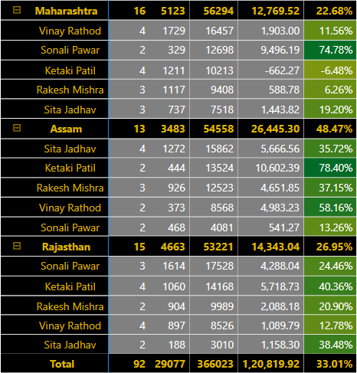

PROFIT %: 45%

PRODUCT ANALYSIS

|  |  |  |  |  |
| --- | --- | --- | --- | --- |
| Product | Category | Detail | State  PRODUCT SUMMARY | Salesperson Performance |
|  |
| 50% Dark Bites | Bites | Order:91  Boxes:23006  Revenue:339k  Profit:167k  Profit%:49% |  |  |
|
| 70% Dark Bites | Bites | Order:91  Boxes:25749  Revenue:370k  Profit:240k  Profit%:65% |  |  |
| 85%  Dark Bars | Bars | Order:97  Boxes:25668  Revenue:370k  Profit:100k  Profit%:27% |  |  | | |
| 99% Dark & Pure | Bars | Order:90  Boxes:18693  Revenue:393k  Profit:248k  Profit%:63% |  |  | | |
| After Nines | Bites | Order:90  Boxes:18693  Revenue:393k  Profit:248k  Profit%:63% |  |  | | |
| Almond Choco | Bars | Order:87  Boxes:24167  Revenue:322k  Profit:198k  Profit%:61% |  |  | | |
| Baker’s choco chips | bars | Order:88  Boxes:23182  Revenue:317k  Profit:29k  Profit%:9% |  |  | | |
| Caramel Stuffed Bars | Bars | Order:98  Boxes:18548  Revenue:400k  Profit:244k  Profit%:61% |  |  | | |
| Choco Coated Almonds | Bites | Order:96  Boxes:18282  Revenue:379k  Profit:318k  Profit%:84% |  |  | | |
| Drinking Coco | Other | Order:100  Boxes:23354  Revenue:392k  Profit:160k  Profit%:41% |  |  | | |
| Eclairs | Bites | Order:91  Boxes:29642  Revenue:311k  Profit:124k  Profit%:40% |  |  | | |
| Fruits & Nut Bars | Bars | Order:89  Boxes:19342  Revenue:399k  Profit:308k  Profit%:77% |  |  | | |
| Manuka honey Choco | Other | Order:96  Boxes:29016  Revenue:405k  Profit:207k  Profit%:51% |  |  | | |
| Milk Bars | Bars | Order:87  Boxes:26033  Revenue:352k  Profit:215k  Profit%:61% |  |  | | |
| Mint Chip Choco | Bars | Order:86  Boxes:18545  Revenue:335k  Profit:229k  Profit%:68% |  |  | | |
| Orange Choco | Bars | Order:97  Boxes:27776  Revenue:372k  Profit:270k  Profit%:73% |  |  | | |
| Organic Choco Syrup | Other | Order:94  Boxes:31112  Revenue:391k  Profit:93k  Profit%:24% |  |  | | |
| Peanut Butter Cubes | Bites | Order:89  Boxes:15276  Revenue:378k  Profit:337k  Profit%:89% |  |  | | |
| Raspberry Choco | Bars | Order:89  Boxes:21536  Revenue:301k  Profit:218k  Profit%:72% |  |  | | |
| Smooth Silky Salty | Bars | Order:100  Boxes:18804  Revenue:387k  Profit:335k  Profit%:87% |  |  | | |
| Spicy Special Slims | Bites | Order:91  Boxes:38452  Revenue:371k  Profit:54k  Profit%:15% |  |  | | |
| White Choco | Other | Order:89  Boxes:22694  Revenue:347k  Profit:201k  Profit%:58% |  |  | | |

Product Corelation:

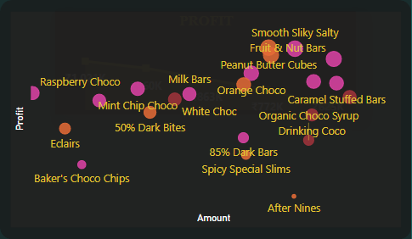

Top Performing Products:

Smooth Silky Salty, Peanut Butter Cubes, Choco Coated Almonds, Fruit &Nut Bars

Poor Performing Products:

After Nines, Baker’s Choco Chips, Spicy Special Slims

Promising Products:

Raspberry Choco, Almond choco, Mint Chip Choco, Eclairs, White Choco

STATE ANALYSIS

ASSAM

PROFIT:

706K

PROFIT%:

55%

REVENUE:

1293K

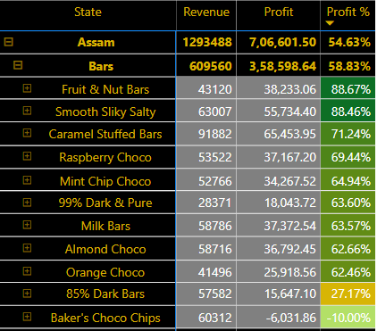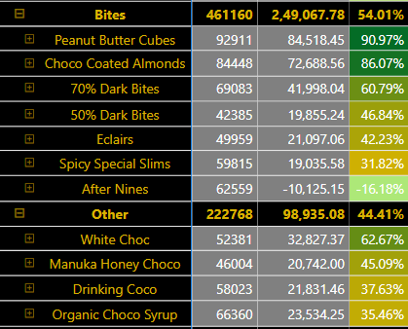

TOP PERFORMER:

WHITE CHOC0LATE

OTHER

BOTTOM PERFORMER:

AFTER NINES

TOP PERFORMER:

1. PEANUT BUTTER CUBES
2. CHOCO COATED ALMONDS

BITES

BOTTOM PERFORMER:

BAKER’S COCO CHIPS

TOP PERFORMER:

1. FRUITS & NUT BARS
2. SMOOTH SILKY SALTY
3. CARAMEL STUFFED BARS

BARS

RAJASTHAN

PROFIT%:

54%

PROFIT:

747K

REVENUE:

1379K

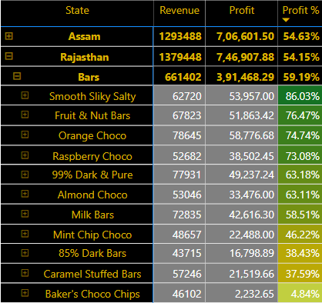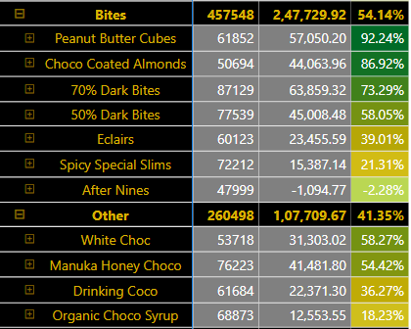

TOP PERFORMER:

WHITE CHOCO

OTHER

BOTTOM PERFORMER:

1. AFTER NINES
2. SPICY SPECIAL SLIMS

TOP PERFORMER:

1. PEANUT BUTTER CUBES
2. CHOCO COATED ALMONDS

BITES

BOTTOM PERFORMER:

BAKER’S COCO CHIPS

TOP PERFORMER:

1. SMOOTH SILKY SALTY
2. FRUITS & NUT BARS
3. ORANGE CHOCO

BARS

BOTTOM PERFORMER:

ORGANIC CHOCO SYRUP

KARNATAKA

REVENUE:

1363K

PROFIT:

726K

PROFIT%:

53%

BARS

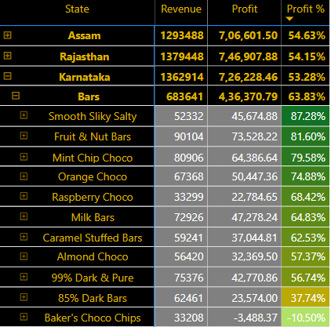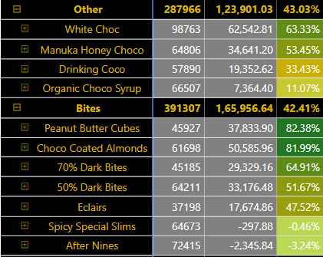

TOP PERFORMER:

WHITE CHOCO

OTHER

BOTTOM PERFORMER:

1. AFTER NINES
2. SPICY SPECIAL SLIMS

TOP PERFORMER:

1. PEANUT BUTTER CUBES
2. CHOCO COATED ALMONDS

BITES

BOTTOM PERFORMER:

BAKER’S COCO CHIPS

TOP PERFORMER:

1. SMOOTH SILKY SALTY
2. FRUITS & NUT BARS
3. ORANGE CHOCO

BOTTOM PERFORMER:

ORGANIC CHOCO SYRUP

MAHARASHTRA

PROFIT:

738K

PROFIT%:

52%

REVENUE:

1410K

BARS

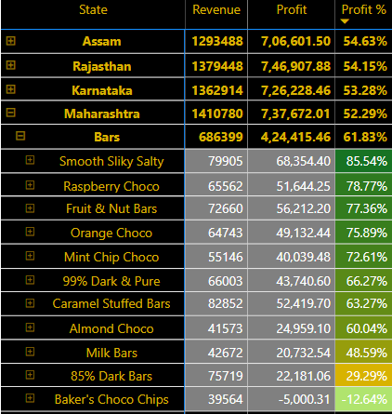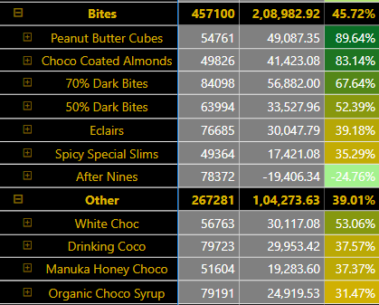

TOP PERFORMER:

WHITE CHOCO

OTHER

TOP PERFORMER:

1. PEANUT BUTTER CUBES
2. CHOCO COATED ALMONDS

BOTTOM PERFORMER:

AFTER NINES

BOTTOM PERFORMER:

BAKER’S COCO CHIPS

BITES

TOP PERFORMER:

1. SMOOTH SILKY SALTY
2. RASPBERRY CHOCO
3. FRUITS & NUT BARS
4. ORANGE CHOCO

PUNJAB

REVENUE:

1264K

PROFIT%:

52%

PROFIT:

652K

BARS

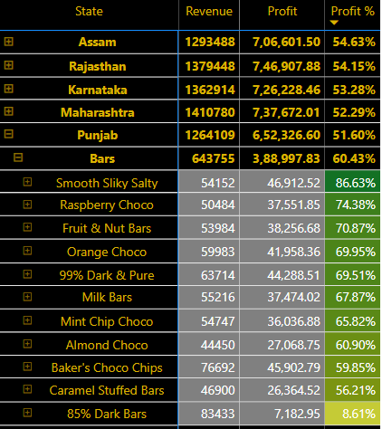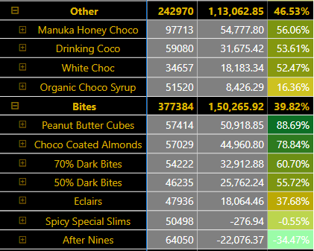

BOTTOM PERFORMER:

ORGANIC CHOCO SYRUP

TOP PERFORMER:

MANUKA HONEY CHOCO

OTHER

BOTTOM PERFORMER:

1. AFTER NINES
2. SPICY SPECIAL SLIMS

TOP PERFORMER:

1. PEANUT BUTTER CUBES
2. CHOCO COATED ALMONDS

BITES

BOTTOM PERFORMER:

85% DARK BARS

TOP PERFORMER:

SMOOTH SILKY SALTY

TAMIL NADU

REVENUE:

1306K

PROFIT%:

51%

PROFIT:

672K

BARS

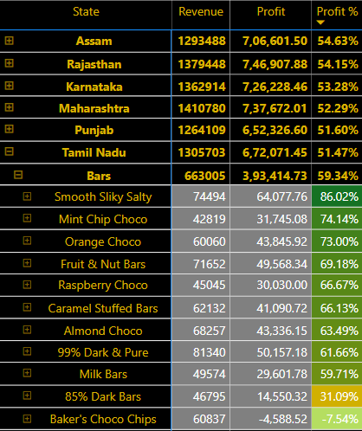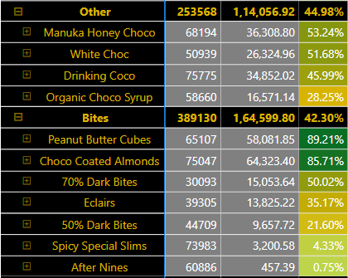

TOP PERFORMER:

MANUKA HONEY CHOCO

OTHER

BOTTOM PERFORMER:

1. AFTER NINES
2. SPICY SPECIAL SLIMS

TOP PERFORMER:

1. PEANUT BUTTER CUBES
2. CHOCO COATED ALMONDS

BITES

BOTTOM PERFORMER:

BAKER’S CHOCO CHIPS

TOP PERFORMER:

SMOOTH SILKY SALTY